Flash Gordon _ Primeiro Laptop
Probably the earliest depiction of a communication device resembling a laptop has been discovered in an ancient Flash Gordon comics by Mende Petreski of Prilep, Macedonia.
Browsing through his comics collection, Mr. Petreski stumbled upon a panel in Politikin Zabavnik weekly published June 14, 1974, featuring the forces of Ming the Merciless using a device which looks a lot like a laptop to talk to their leader.
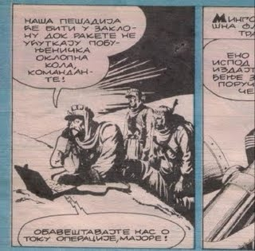Translation: "Our infantry will stay in the cover until the rockets silence the rebel armored cars, commander" - "Keep us posted about the flow of the operation, Major!"
This particular comics represents a Serbian translation of an episode drawn around 1937 by Alex Raymond. The title the magazine used is "Ming's Prisoners", while the contents probably covers part of the story "The Outlaws of Mongo" which the Flash Gordon Wiki attributes to Alex Raymond and Don Moore, originally published as Sunday comics from August 15, 1937 – June 5, 1938.
The Wiki mentions the spacephone as a "communication device used on Mongo," but makes no mention about the laptop-like apparatus.
The leading Macedonian portal On.net broke the news of this discovery first. It can be of interest to computer science historians and comics lovers.
